Chess Game
Software Requirements Specification
Version | 1.0
Date | September 21, 2026
Format | Based on IEEE 830 / ISO/IEC/IEEE 29148
Models | Use case, class, sequence, activity, collaboration, state chart and interaction diagrams

Contents

1. Introduction

1.1 Purpose
This document specifies the requirements of the Chess Game, a two-player chess application. It describes what the system must do: create and manage all 32 pieces, validate every move, and track the game state, including check and checkmate. It is intended for developers, testers, project supervisors and anyone who needs to review or approve the system.

1.2 Scope
The Chess Game lets two players play a complete game of chess on one device. The software enforces the rules of chess so that an illegal move can never be played.
In scope: board and piece management, move input, move validation, special moves (castling, en passant, promotion), detection of check, checkmate, stalemate and draws, resignation, draw offers, move history, undo, and saving or loading a game.
Out of scope for version 1.0: computer opponent, online multiplayer, player ratings, and opening or engine analysis. The design should leave room to add them later.

1.3 Definitions and abbreviations
Term | Meaning
SRS | Software Requirements Specification
Piece | One of 32 playing units: 16 white and 16 black. Each side has 1 king, 1 queen, 2 rooks, 2 bishops, 2 knights and 8 pawns.
Square | One of the 64 cells of the board, named by file (a to h) and rank (1 to 8), for example e4.
Check | A king is attacked by at least one opposing piece.
Checkmate | A king is in check and the side to move has no legal move. That side loses.
Stalemate | The side to move is not in check but has no legal move. The game is a draw.
Castling | A special king and rook move made together in one turn.
En passant | A special pawn capture of an enemy pawn that has just advanced two squares.
Promotion | A pawn that reaches the last rank is replaced by a queen, rook, bishop or knight.
Legal move | A move that follows the piece's movement rule and does not leave the mover's own king in check.
UML | Unified Modeling Language

1.4 References
- IEEE Std 830-1998, Recommended Practice for Software Requirements Specifications
- ISO/IEC/IEEE 29148:2018, Requirements engineering
- FIDE Laws of Chess (rules of play)
- OMG Unified Modeling Language specification

1.5 Overview of this document
Section 2 gives the general context of the product. Section 3 lists the detailed requirements. Section 4 presents the UML models. Section 5 links use cases to requirements.

2. Overall description

2.1 Product perspective
The Chess Game is a self-contained application with no dependency on external services. It consists of a user interface, a game controller, a rules engine (move validator) and a model of the board and pieces. These parts are kept separate so that the rules can be tested without the interface.

2.2 Product functions
- Set up the board with all 32 pieces in their standard positions.
- Let players select a piece and move it, alternating turns starting with White.
- Validate each move against the rules of the piece, the board and king safety.
- Apply captures, castling, en passant and pawn promotion.
- Detect and announce check, checkmate, stalemate and draws.
- Support resignation, draw offers, undo, move history and save or load.

2.3 User classes
User | Description
Player | Primary user. Two players take the White and Black sides. They may be beginners or experienced players and need no technical knowledge.
Maintainer | Secondary user. Developer or tester who extends or verifies the rules and code.

2.4 Operating environment
The product is platform independent in design. The target platform (desktop or web) is chosen at implementation time and must provide a display, a pointing device or touch input, and local storage for saved games.

2.5 Design and implementation constraints
- The rules implemented must match the FIDE Laws of Chess for the features listed in scope.
- The design must be object oriented, with one class per piece type.
- Each game must contain exactly 32 pieces at the start and never more during play.

2.6 Assumptions and dependencies
- Both players share one device and take turns (hot-seat play).
- Players know the basic rules of chess. The software helps by showing legal moves.
- No network connection is needed.

3. Specific requirements

3.1 External interface requirements
Interface | Requirement
User interface | An 8 by 8 board with alternating light and dark squares, file letters and rank numbers, piece images, a status bar (turn, check, result), a move history list and buttons for new game, undo, resign, offer draw, save and load.
Hardware | Standard display and mouse, keyboard or touch screen.
Software | No third-party services. Saved games use a plain text format that stores the position and the move list.
Communication | None in version 1.0.

3.2 Functional requirements
A. Board and piece management
ID | Requirement | Priority
FR-1 | The system shall create an 8 by 8 board of 64 squares identified by file a to h and rank 1 to 8. | High
FR-2 | The system shall create 32 pieces at the start of a game: 16 white and 16 black, each side with 1 king, 1 queen, 2 rooks, 2 bishops, 2 knights and 8 pawns, placed in the standard starting positions. | High
FR-3 | Each piece shall record its colour, type, current square, whether it has moved, and whether it has been captured. | High
FR-4 | The system shall remove a captured piece from the board and add it to the capturing player's captured list. The number of pieces on the board shall never increase during a game. | High
FR-5 | White shall move first and turns shall alternate strictly after each legal move. | High
B. Move input
ID | Requirement | Priority
FR-6 | The system shall let the current player select one of their own pieces and shall highlight all legal destination squares for it. | High
FR-7 | The system shall ignore or reject the selection of an empty square or an opponent's piece as the piece to move. | High
FR-8 | The system shall accept a move by selecting the piece and the destination square, and may also accept typed coordinate input such as e2e4. | Medium
C. Move validation
ID | Requirement | Priority
FR-9 | The system shall validate every move against the movement rule of the moving piece (see 3.3). | High
FR-10 | The system shall reject a move if another piece blocks the path. Only the knight may jump over pieces. | High
FR-11 | The system shall reject a move to a square occupied by a piece of the same colour. | High
FR-12 | The system shall reject any move that leaves the mover's own king in check. This includes moving a pinned piece and moving the king onto an attacked square. | High
FR-13 | When a move is rejected, the system shall show the reason, leave the board unchanged and let the same player try again. | High
FR-14 | Validation shall finish before any change is made to the board, so that a move is either fully applied or not applied at all. | High
D. Special moves
ID | Requirement | Priority
FR-15 | The system shall allow castling only if the king and the chosen rook have not moved, the squares between them are empty, the king is not in check, and the king does not cross or land on an attacked square. | High
FR-16 | The system shall allow en passant capture only on the turn immediately after an enemy pawn advanced two squares next to the capturing pawn. | Medium
FR-17 | When a pawn reaches the last rank, the system shall ask the player to choose a queen, rook, bishop or knight and replace the pawn with it. | High
E. Game state
ID | Requirement | Priority
FR-18 | After every move, the system shall determine whether the opponent's king is in check and shall display a check notice. | High
FR-19 | The system shall declare checkmate when the side to move is in check and has no legal move, end the game and announce the winner. | High
FR-20 | The system shall declare stalemate when the side to move is not in check and has no legal move, and end the game as a draw. | High
FR-21 | The system shall detect a draw by insufficient material, threefold repetition, the fifty-move rule, or agreement of both players. | Medium
FR-22 | The game status shall always be exactly one of: Not started, Active, Check, Checkmate, Stalemate, Draw, Resigned. No move shall be accepted after Checkmate, Stalemate, Draw or Resigned. | High
F. Game control and storage
ID | Requirement | Priority
FR-23 | A player shall be able to resign, which ends the game and gives the win to the opponent. | High
FR-24 | A player shall be able to offer a draw. The game ends as a draw only if the opponent accepts. | Medium
FR-25 | The system shall record every move in algebraic notation and show the list during play. | Medium
FR-26 | The system shall let players undo the last move, restoring any captured piece, castling, en passant or promotion. | Low
FR-27 | The system shall let players start a new game at any time after confirming. | High
FR-28 | The system shall save a game to local storage and load it later with the same position, turn and history. | Low

3.3 Piece movement rules
Piece | Count per side | Movement rule
King | 1 | One square in any direction. It may not move onto an attacked square. It may castle (FR-15).
Queen | 1 | Any number of squares along a rank, file or diagonal, without jumping.
Rook | 2 | Any number of squares along a rank or file, without jumping. Takes part in castling.
Bishop | 2 | Any number of squares along a diagonal, without jumping.
Knight | 2 | Two squares in one direction and one square at a right angle (an L shape). It may jump over pieces.
Pawn | 8 | One square forward, or two squares forward from its starting rank if both squares are empty. Captures one square diagonally forward. Can capture en passant (FR-16) and is promoted on the last rank (FR-17).

3.4 Non-functional requirements
ID | Category | Requirement
NFR-1 | Performance | Validating a single move shall take under 100 ms. Detecting check, checkmate and stalemate after a move shall take under 500 ms on typical hardware.
NFR-2 | Reliability | An illegal move shall never change the game state. The rules engine shall follow the FIDE Laws for all features in scope.
NFR-3 | Usability | A new user shall be able to make a first move within one minute without instructions. The selected piece, legal destinations and a king in check shall be visibly marked.
NFR-4 | Accessibility | Text and board colours shall have sufficient contrast, and all actions shall be possible by keyboard as well as pointer.
NFR-5 | Maintainability | Each piece type shall be its own class so that a rule can be changed without touching other pieces. The rules engine shall be separate from the user interface.
NFR-6 | Testability | Every piece rule, special move and end-of-game condition shall have automated tests, with at least 90 percent coverage of the rules engine.
NFR-7 | Portability | The rules engine shall not depend on any user interface library.
NFR-8 | Data integrity | A saved game that is damaged or invalid shall be rejected with a clear message and shall not crash the application.

4. System models (UML)
The diagrams below model the Chess Game from different views. Sequence and collaboration diagrams are both kinds of interaction diagram, so 4.7 adds an interaction overview diagram that ties the interactions together.

4.1 Use case diagram
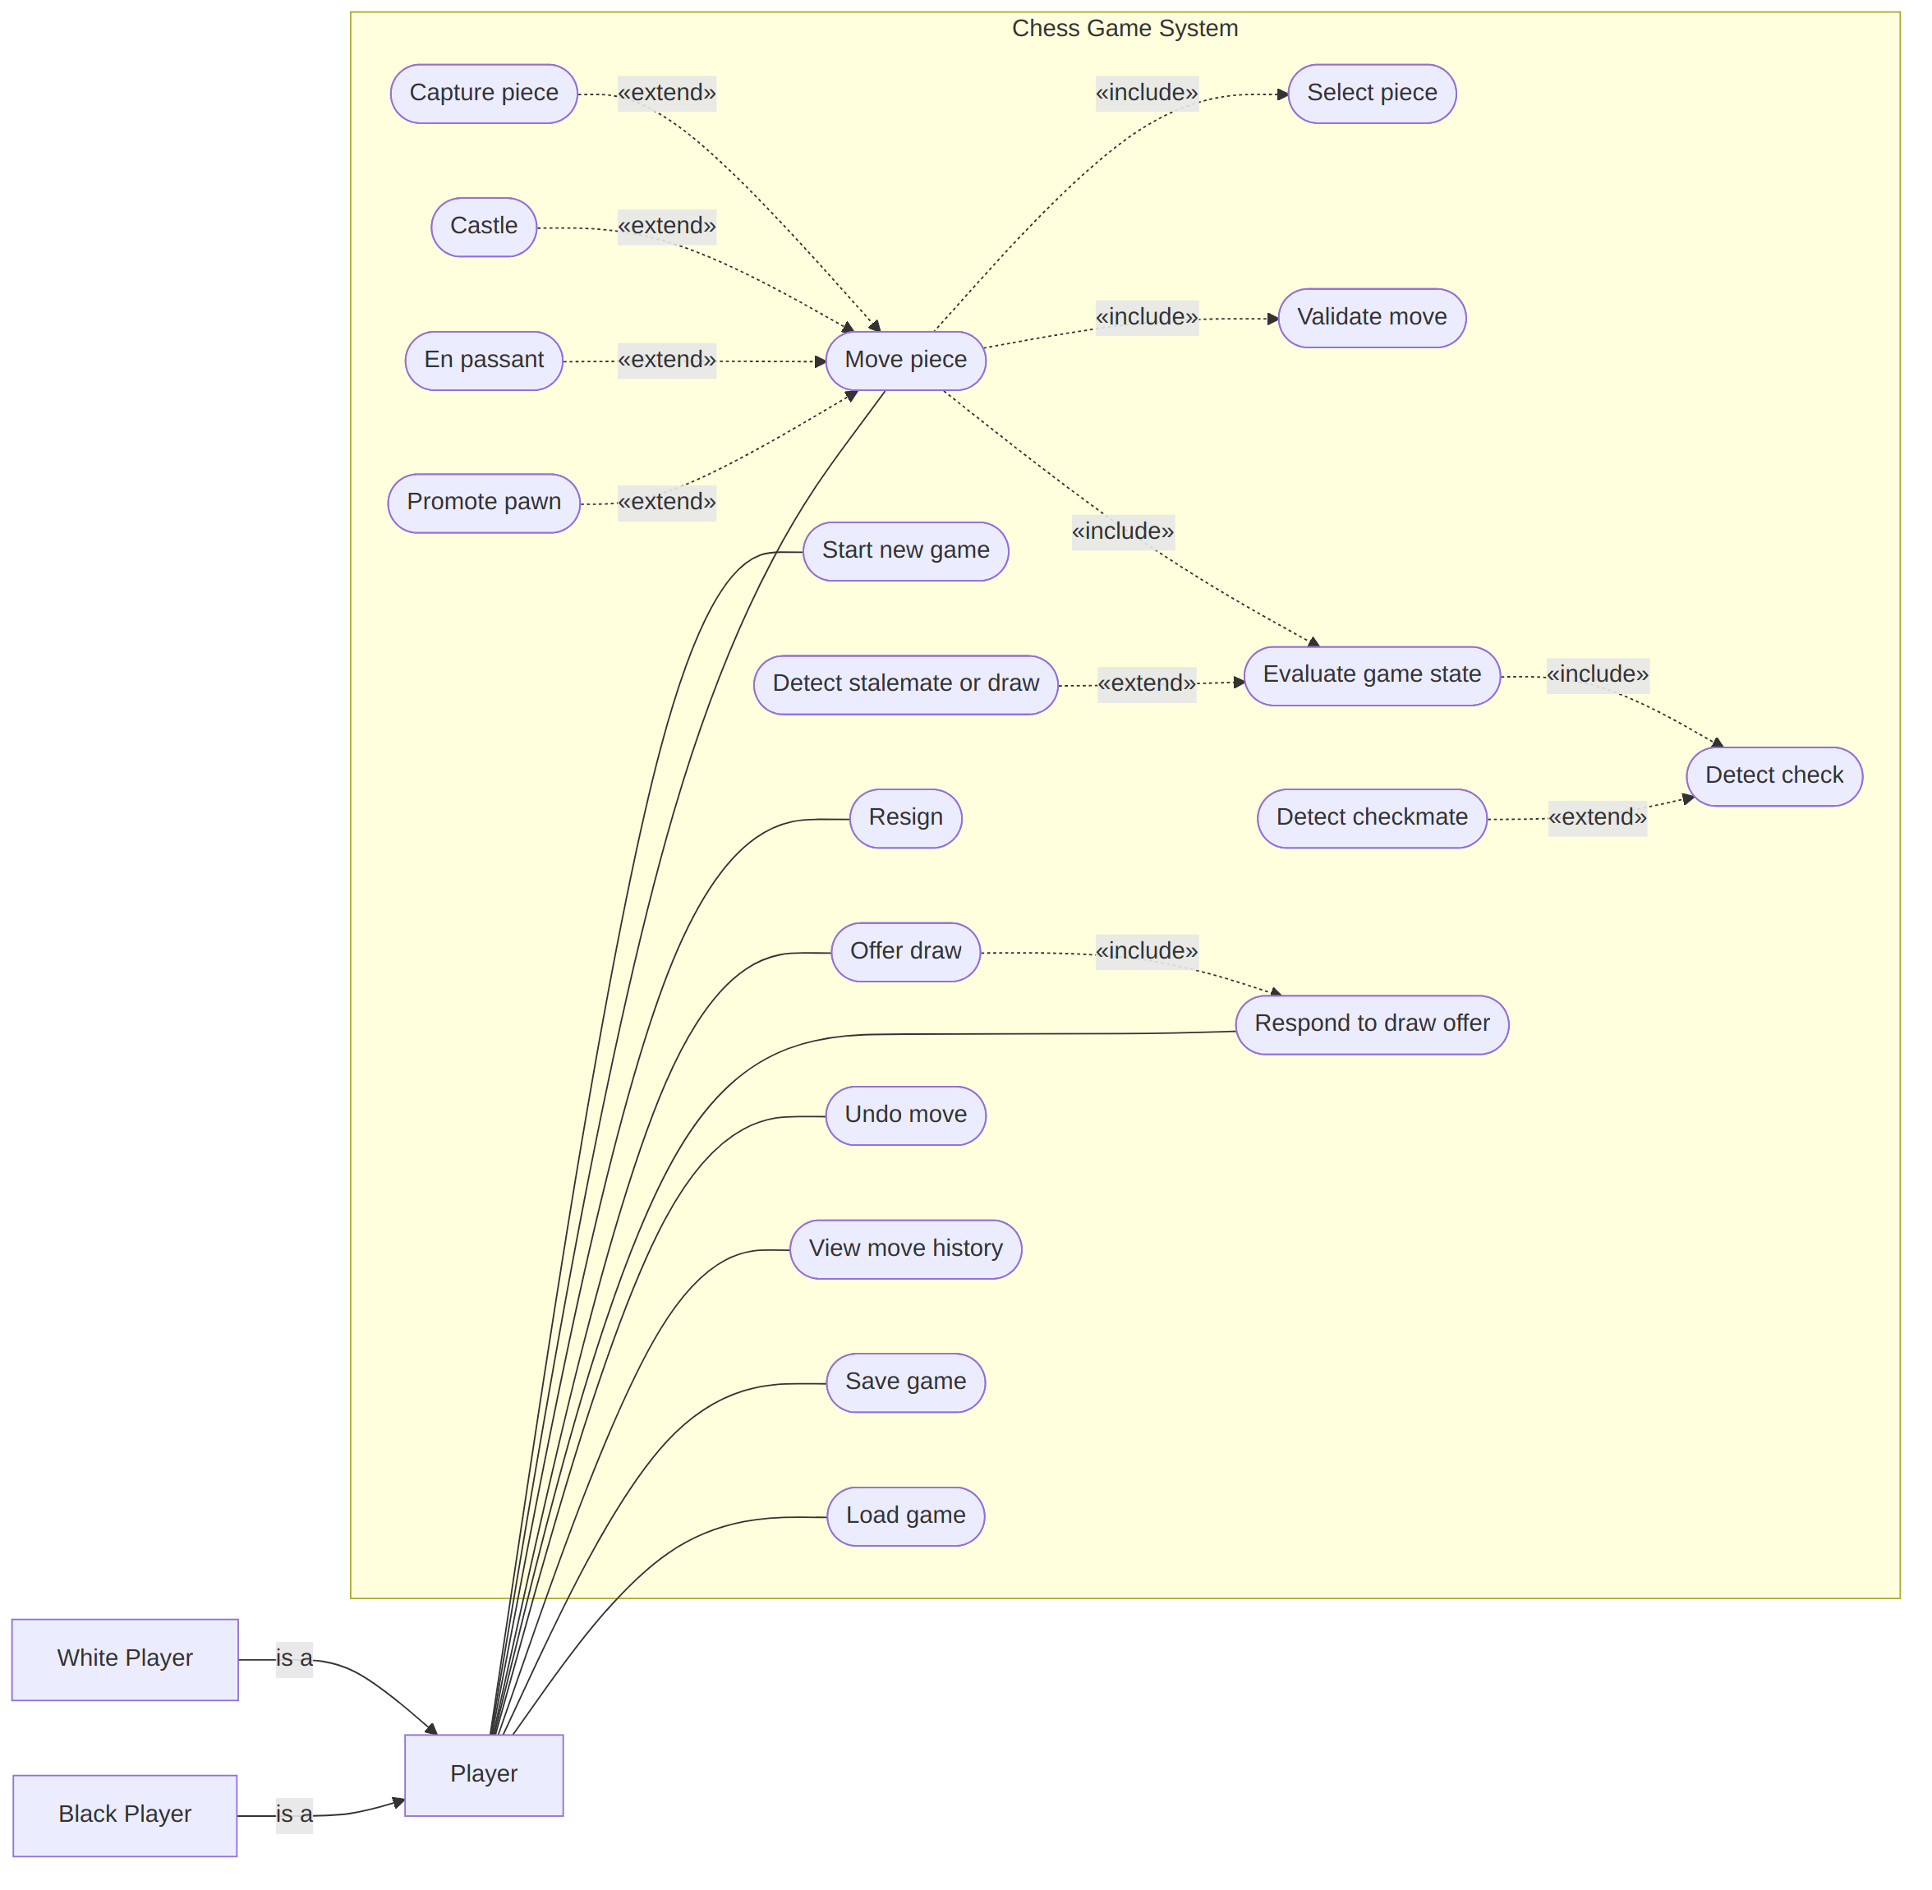
Figure 4.1 Use case diagram. White Player and Black Player are the two roles of the actor Player, so every Player use case is available to whichever side is acting. The opponent of the player who offers a draw performs "Respond to draw offer".
Use case description: Move piece (UC3)
Actor | Player (the side whose turn it is)
Precondition | The game status is Active or Check, and it is the player's turn.
Main flow | 1. The player selects one of their own pieces.  2. The system highlights the legal destinations.  3. The player selects a destination.  4. The system validates the move.  5. The system moves the piece and removes any captured piece.  6. The system checks the opponent's king for check, checkmate and stalemate.  7. The system updates the status and passes the turn.
Alternative flows | 4a. The move is illegal: the system shows the reason and returns to step 1.  5a. The move is castling, en passant or a capture: the matching extension is applied.  5b. A pawn reaches the last rank: the player chooses a promotion piece.
Postcondition | The board, move history and game status reflect the new move, and the opponent is to move, unless the game has ended.

4.2 Class diagram
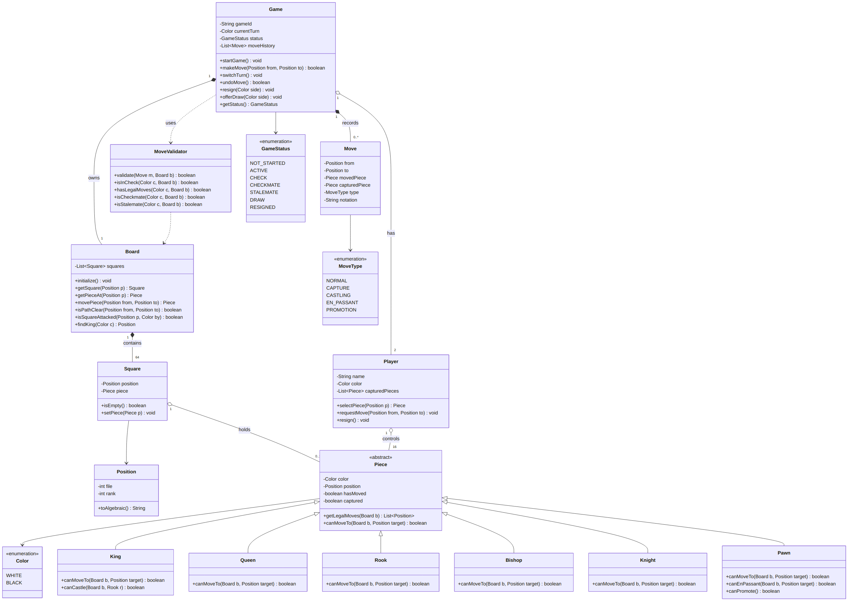
Figure 4.2 Class diagram. Each of the two players controls 16 pieces, giving 32 pieces on a board of 64 squares.

4.3 Sequence diagram
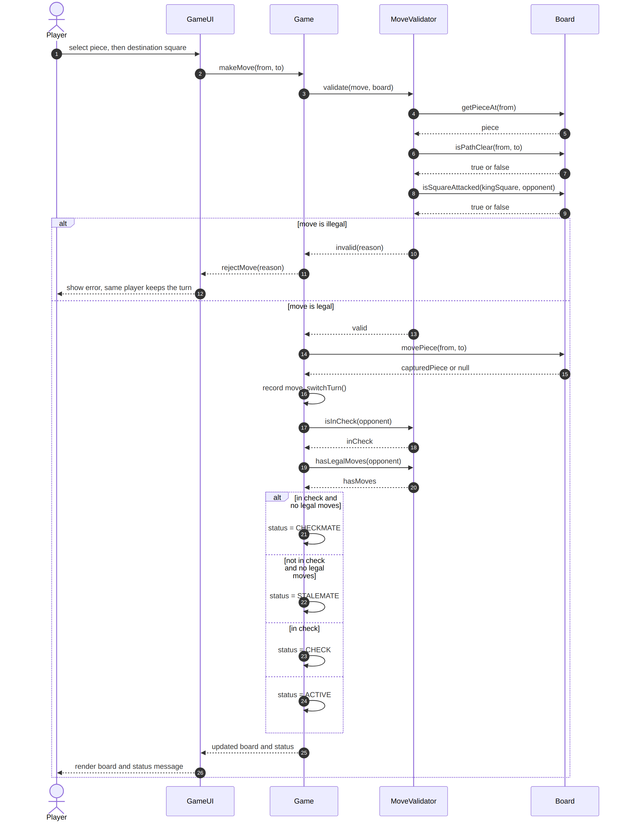
Figure 4.3 Sequence diagram for making a move, from selection to the new game status.

4.4 Activity diagram
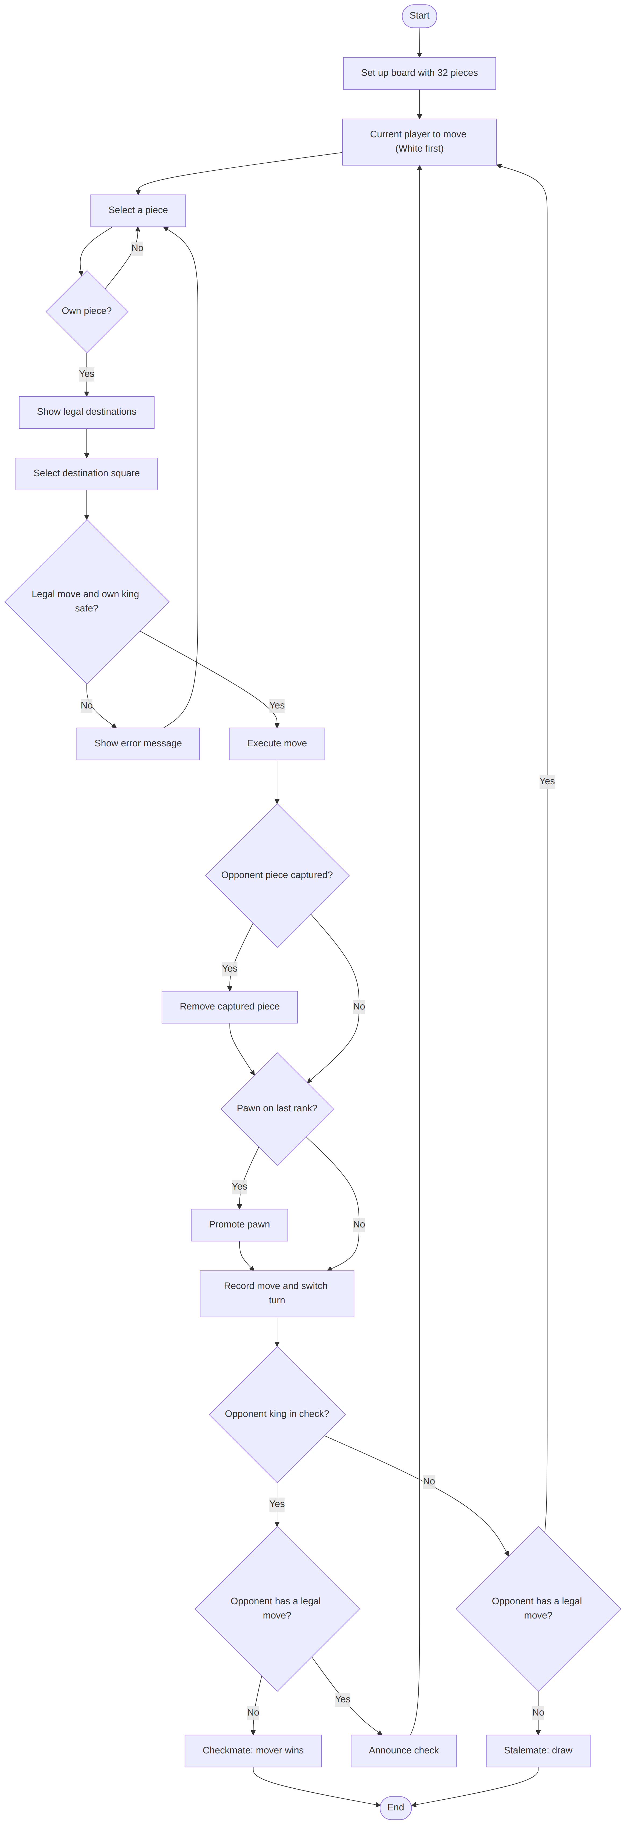
Figure 4.4 Activity diagram of one turn and the end-of-game checks. After each turn the flow returns to the top for the other side.

4.5 Collaboration diagram
A collaboration (communication) diagram shows the same move as Figure 4.3, but focuses on the links between objects. Numbers give the order of messages.
Figure 4.5 Collaboration diagram for the Move piece use case.

4.6 State chart diagram
The states match the GameStatus values of the class diagram. Whose turn it is stays in the separate currentTurn attribute, and "Check" means that the player to move is in check. After every valid move the game passes through a decision point that evaluates the new position for the side that must move next.
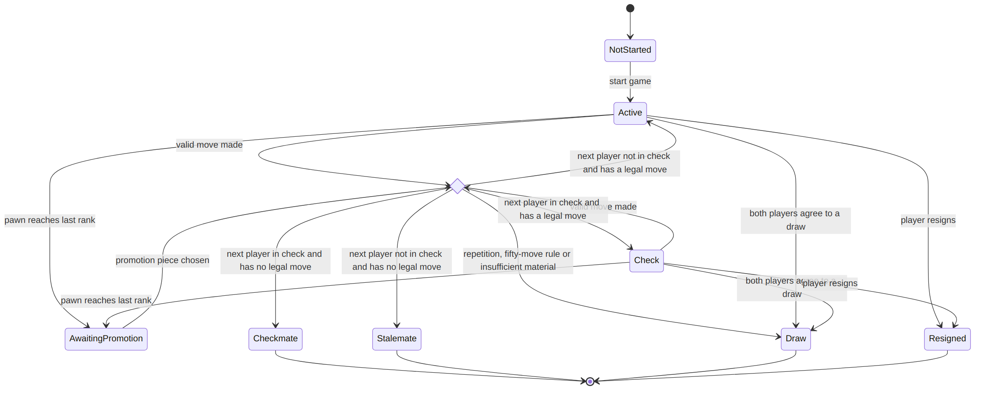
Figure 4.6 State chart of a game. A rejected illegal move causes no transition, because the game state stays unchanged (FR-13). Checkmate, Stalemate, Draw and Resigned are final states that accept no further moves (FR-22).

4.7 Interaction diagram (interaction overview)
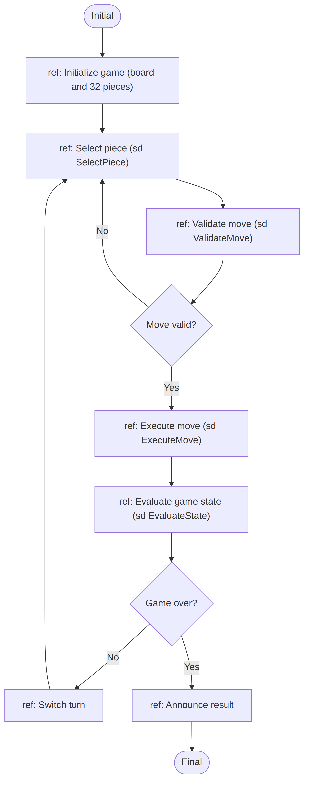
Figure 4.7 Interaction overview diagram. Each "ref" box stands for an interaction, such as the sequence in Figure 4.3, that runs at that point.

5. Traceability
Use case | Functional requirements
UC1 Start new game | FR-1, FR-2, FR-5, FR-27
UC2 Select piece | FR-6, FR-7
UC3 Move piece | FR-8, FR-13, FR-14
UC4 Validate move | FR-9, FR-10, FR-11, FR-12
UC5 Capture piece | FR-4
UC6 Castle | FR-15
UC7 En passant | FR-16
UC8 Promote pawn | FR-17
UC9 Evaluate game state | FR-22
UC10 Detect check | FR-18
UC11 Detect checkmate | FR-19
UC12 Detect stalemate or draw | FR-20, FR-21
UC13 Resign | FR-23
UC14 Offer draw | FR-24
UC15 Respond to draw offer | FR-21, FR-24
UC16 Undo move | FR-26
UC17 View move history | FR-25
UC18 Save game | FR-28
UC19 Load game | FR-28

